Stroop-like Arrows Task
Based off of Baldo, J. V., Shimamura, A. P., & Prinzmetal, W. (1998). Mapping symbols to response modalities: interference effects on Stroop-like tasks. Perception and Psychophysics, 60(3), 427- 437.

In our adaptation of a stroop-like arrows task, participants are shown red and blue arrows and must press a button (green rectangle) either in the congruent direction of the arrow when it is red or in the incongruent direction of the arrow when it is blue. In other words, when the arrow is red and points to the left, the respondent should press the button in the same direction as the arrow (to the left). On the other hand, when the arrow is blue and points to the left, the respondent should press the button in the opposite direction as the arrow (to the right). Respondents must complete the task of 30 total arrows as quickly as possible. The task aims to measure aspects of executive control, such as attentional control and inhibitory control. It has been used with our study population in the past.

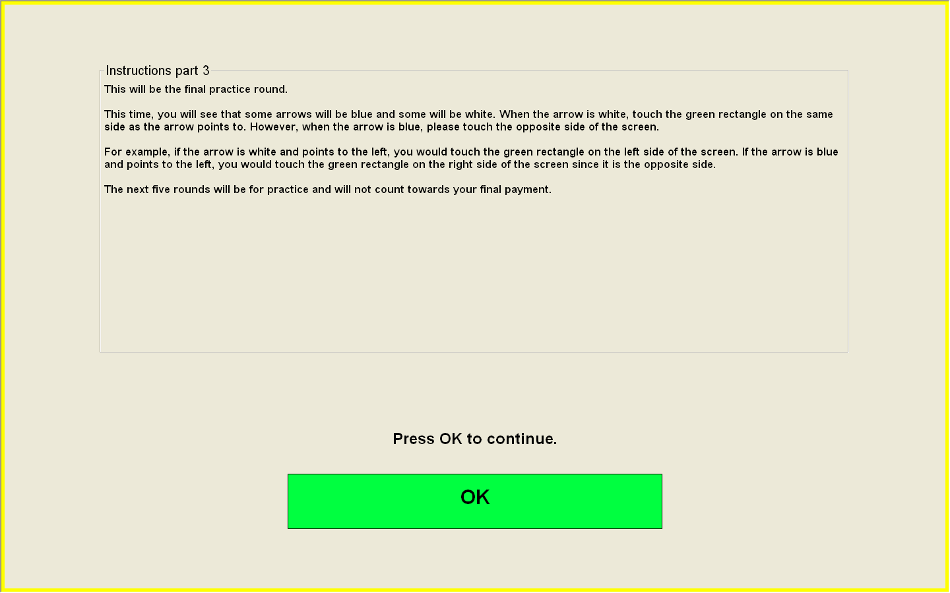
Example instructions screen:
Example blue arrow (touch opposite side of screen)
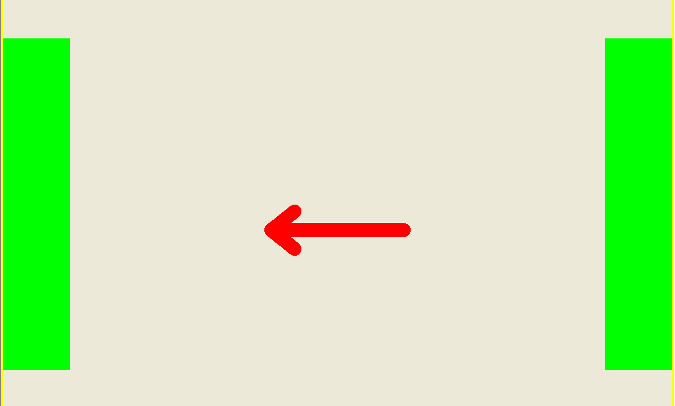
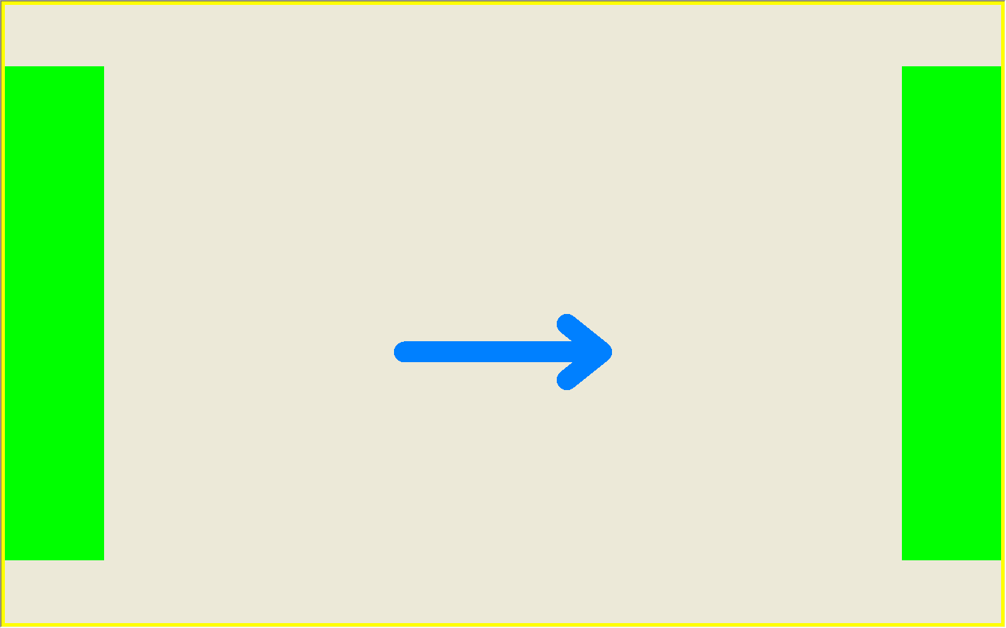

Example red arrow (touch same side of screen)

