Risk Preferences Task

To elicit risk preferences, respondents are asked to make 27 decisions between two choices, Jar A and Jar B. Each jar has two balls with a 50% probability of being chosen at random. Series 1 elicits choices over gains; Series 2 elicits choices over losses; and Series 3 elicits choices over mixed lotteries.

Series:
- In Series 1 (10 decisions), Jar A always contains a blue ball worth 400 KSH and a red ball worth 300 KSH; Jar B contains an orange ball that is always worth 50 KSH while the green ball contains some value X that varies from 620 KSH to 1300 KSH.
- In Series 2 (10 decisions), Jar A always contains a blue ball representing a loss of 400 KSH and a red ball representing a loss of 300 KSH; Jar B contains an orange ball that always represents a loss of 950 KSH while the green ball contains some value X that varies from losing 170 KSH to losing 460 KSH.
- In Series 3 (7 decisions), Jar A contains a red ball with a gain of either 10 KSH, 40 KSH, or 250 KSH and a blue ball with a loss of either 40 KSH or 80 KSH; Jar B contains a green ball with a gain of 300 KSH and an orange ball with a loss of either 110 KSH, 140 KSH, 160 KSH, or 210 KSH.

The options within each Series are depicted below:
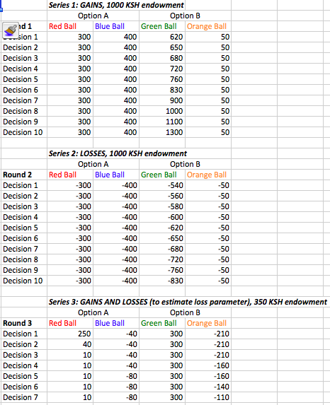
Example Instructions screen:

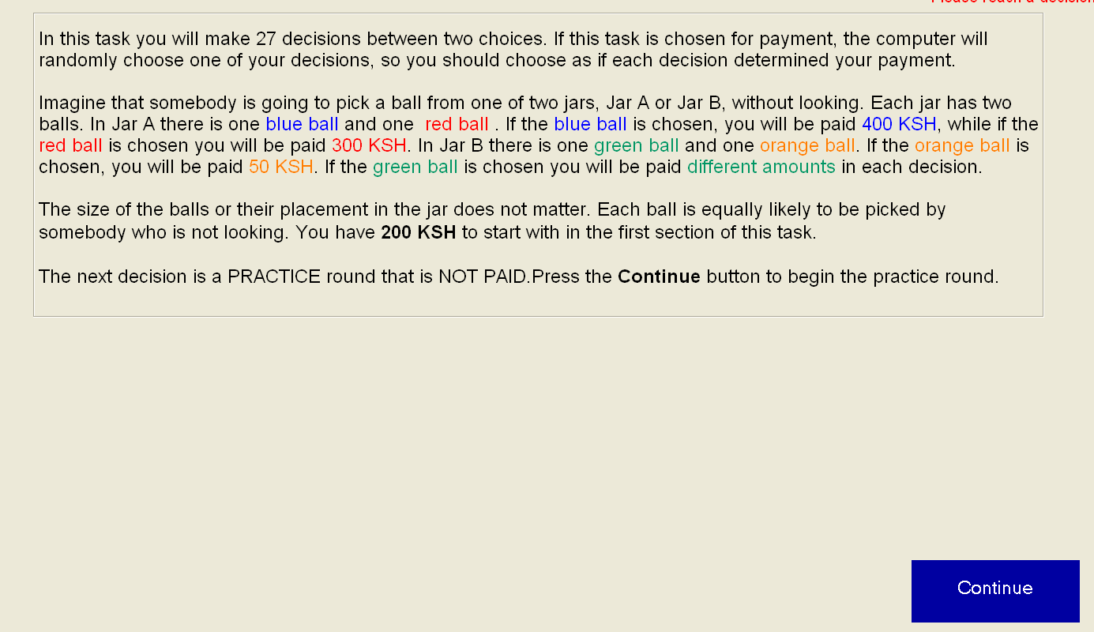

Example decisions:

Series 1 Example
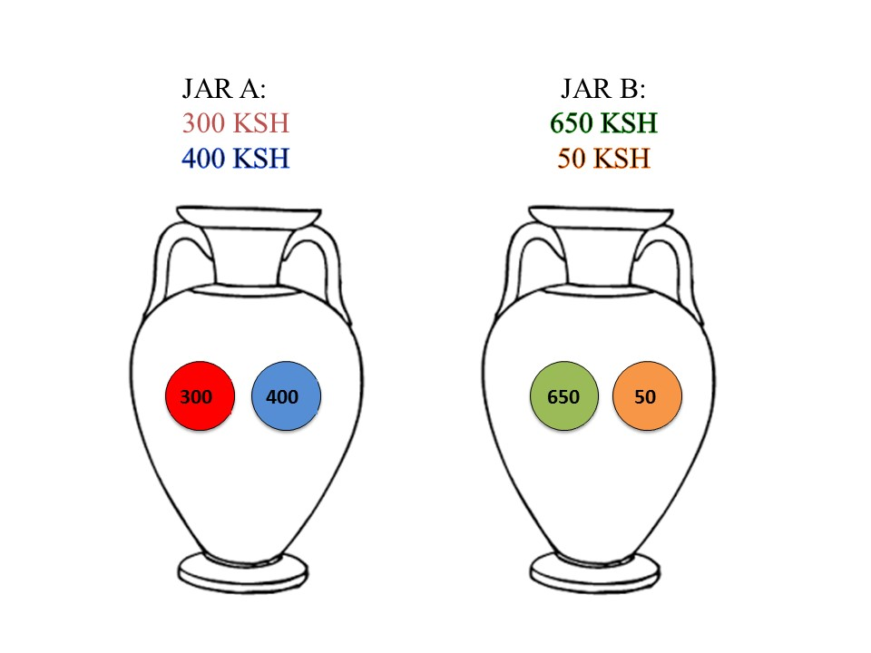
Series 2 Example
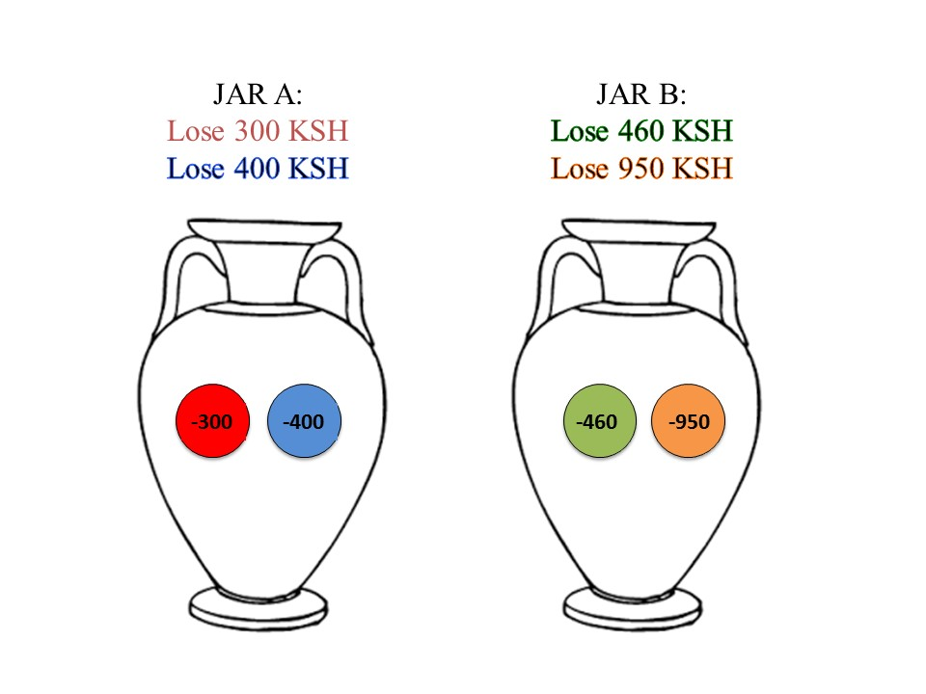

Series 3 Example
