Multiple Price List
Coller, M., & Williams, M. (1999). Eliciting Individual Discount Rates.
Experimental Economics 2, 107–127.

The basic experimental design for eliciting individual discount rates introduced by Coller and Williams (1999) asked subjects an extremely simple question: do you prefer $100 today or $100 + x tomorrow, where x is some positive amount? If the subject prefers the $100 today then we can infer that the discount rate is higher than x% per day; otherwise, we can infer that it is x% per day or less.

This experiment was expanded upon by Harrison, Lau, and Williams (2002) [HLW], Coller, Harrison, and Rutstrom (2003), and Harrison, Lau, Rutstrom, and Sullivan (2004) [HLRS]. Across all time horizons considered by HLW, payoffs to any one subject could range from 3,000 DKK up to 12,333 DKK. The exchange rate in 1997, when the HLW experiments were conducted was approximately 6.7 DKK per US dollar, so this range converts to $450 and $1840. HLW finds a discount rate of mean of 28.1% for horizons of 6, 12, 24, and 36 months.

Subjects in the HLRS experiments were given payoff tables as indicated below. They were told that they must choose between payment Options A and B for each of the 10 payoff alternatives. Option A was 3000 DKK in all sessions. Option B paid 3000 DKK + X DKK, where X ranged from annual rates of return of 5% to 50% on the principal of 3000 DKK, compounded quarterly to be consistent with general Danish banking practices on overdraft accounts.

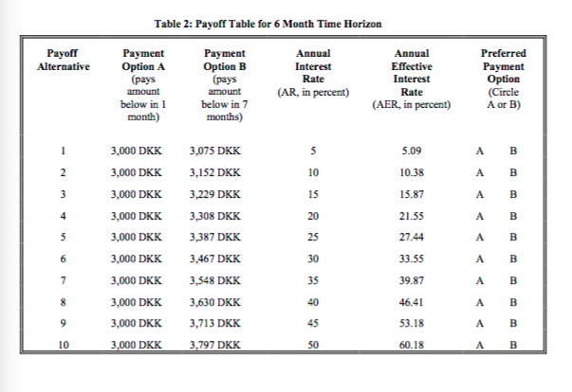
Our adaptation of the task:

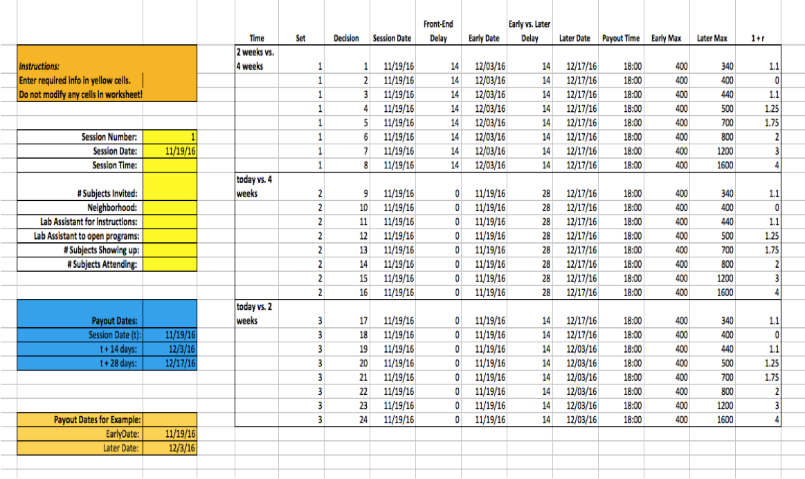
In our adapted version of the task, respondents are faced with 24 decisions in the gains domain (similar to what is outlined above) and 24 decisions in the losses domain (total of 48 decisions). In the gains framework, respondents are asked to choose between a smaller, sooner payment or a larger, later payment. In the losses framework, respondents are given an initial endowment of 1600 KSH sooner and 1600 KSH later and are asked to make decisions between a smaller sooner loss or a larger, later loss in the future. Below is an example of the discrete choices between a smaller, sooner payment/loss or a larger, later payment/loss that participants will make across three timeframes: 2 weeks from today vs. 4 weeks from today, today vs. 4 weeks from today, and today vs. 2 weeks from today. The losses domain consists of the same amounts and timeframes, with the only difference being that values are shown as negative amounts to indicate a loss from the initial endowment of 1600 KSH earlier and 1600 KSH later:

Instructions screen

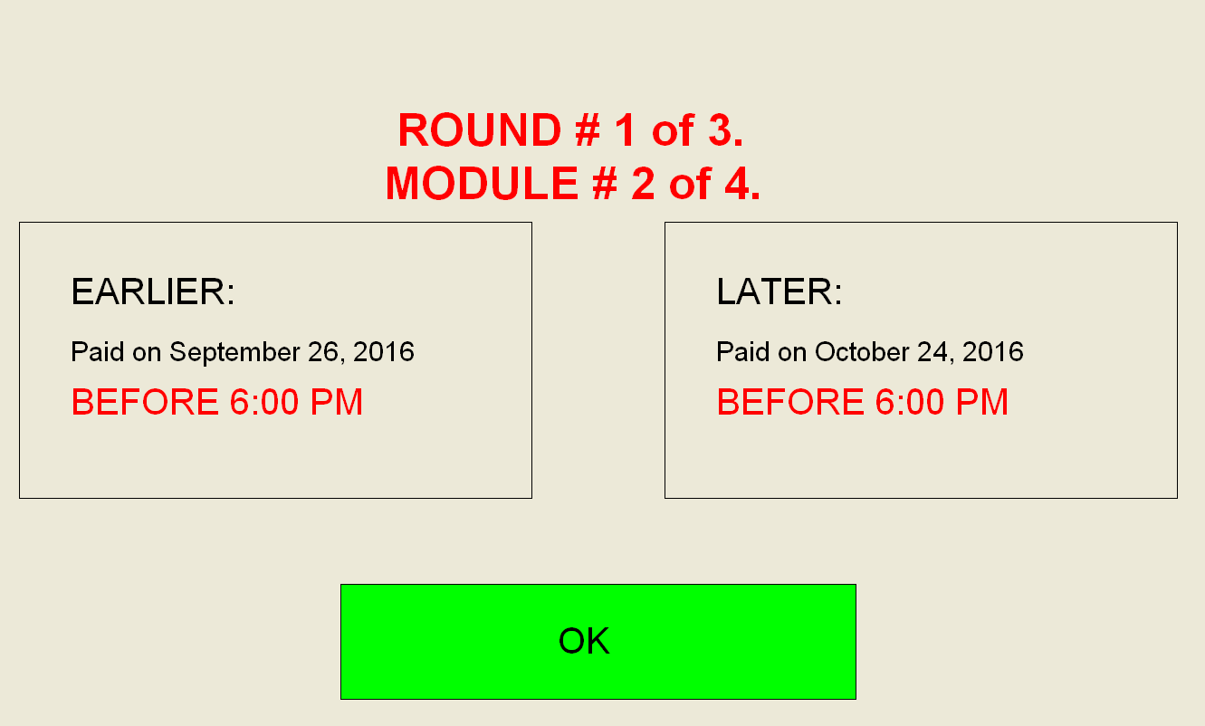

Gains example (decision 1)



Losses example (decision 1)



