Effort Discounting Task (developed internally)

The effort-based discounting task is similar to the Multiple Price List design referenced in 1.9, however, instead of eliciting preferences over money, the task elicits preferences over effort.

In this task, respondents are faced with 18 decisions across three timeframes: 2 weeks from today vs. 4 weeks from today, today vs. 4 weeks from today, and today vs. 2 weeks from today. Respondents choose between making a phone call X number of times on a given day, where X phone calls varies on the future date within each timeframe. The calls need to be completed between 6 PM and 10 PM on the given day and must be 10 minutes apart.
Participants are informed that they will receive a reminder every hour in the four-hour interval during which they are allowed to make the phone call to minimize confounding factors, such as forgetting.
The table below indicates the number of calls on the earlier date and the number of calls on the later date for each timeframe:
Number of calls today/in 2 weeks | Number of calls in 2 weeks/4 weeks
2 | 1
2 | 2
2 | 3
2 | 4
2 | 5
2 | 6

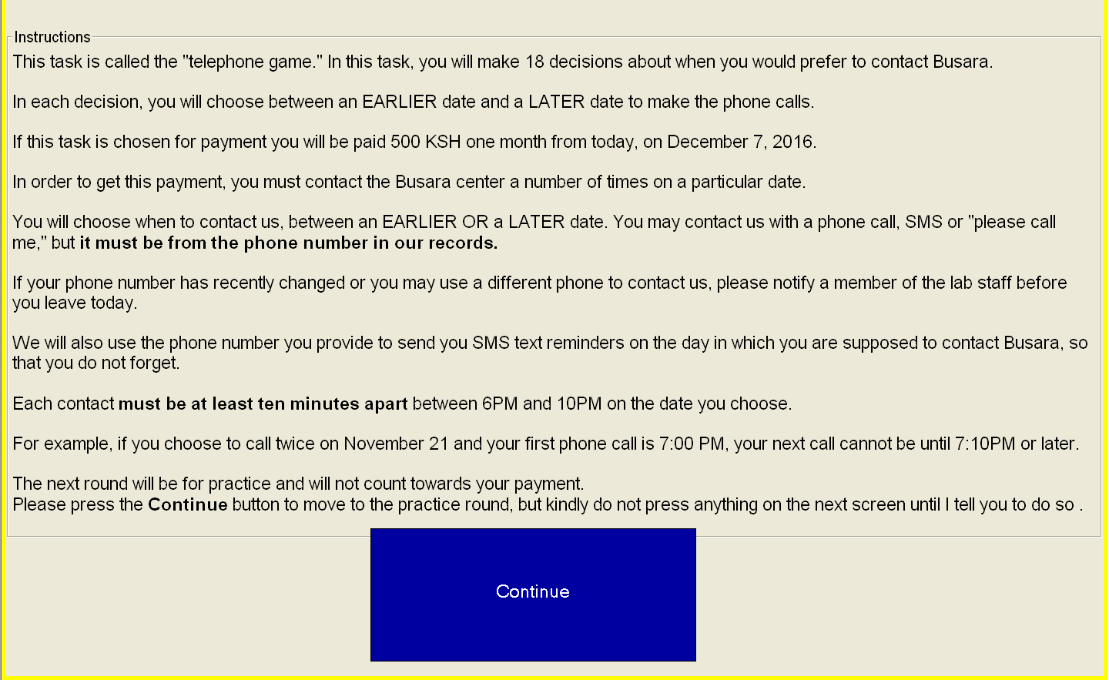
Sample Instructions screen:

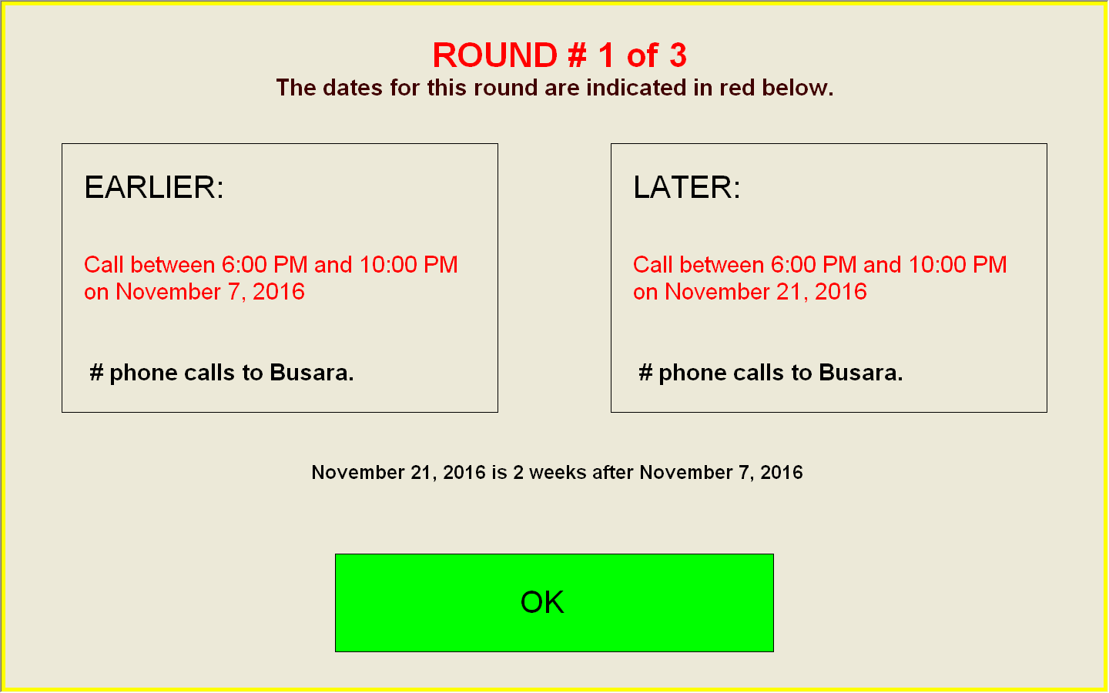

Sample decision screen

