Convex Time Budgets

Subjects faced 45 convex budget decisions. These 45 budgets involved nine combinations of starting times, t, and delay lengths, k, with annual interest rates that varied from zero to over 1,000 percent per year.
A (3 × 3) design was implemented with three sooner payment dates, t = (0, 7, 35) days from the experiment date, crossed with three delay lengths, (k = 35, 70, 98) days. Thus there are nine (t, k) cells and within each cell are five CTB questions, generating 45 choices for each subject. We refer to each (t, k) combination as a “choice set.” The t and k combinations used in our study were selected to avoid holidays (including Valentine’s Day), school vacations, spring break, and final examination weeks. Payments were scheduled to arrive on the same day of the week (t and k are both multiples of 7), to avoid differential weekday effects.
In each CTB question, subjects were given a budget of 100 tokens. Tokens allocated to sooner payments had a value of at while tokens allocated to later payments had a value of at+k. In most cases, at+k was $0.20 per token and at varied from $0.20 to $0.10 per token. Note that at+k/at = 1 + r, the gross interest rate over k days, so (1 + r)1/k gives the standardized daily interest rate. Daily net interest rates in the experiment varied considerably across the 45 budgets, from 0 to around 1 percent per day implying annual interest rates of between 0 and 1,300 percent (compounded quarterly).
Each choice set featured at+k = $0.20 and at = $0.16 (1 + r = 1.25). In eight of the nine choice sets, one convex budget represented a pure income shift relative to this choice. This was implemented with at+k = $0.25 and at = $0.20 (1 + r = 1.25 again). In the remaining choice set, (t,k)=(7,70), we instead implemented at = $0.20 and at+k = $0.20, a zero percent interest rate. Table 1 shows the token rates, interest rates, standardized daily interest rates, and corresponding annual interest rates for all 45 budgets.
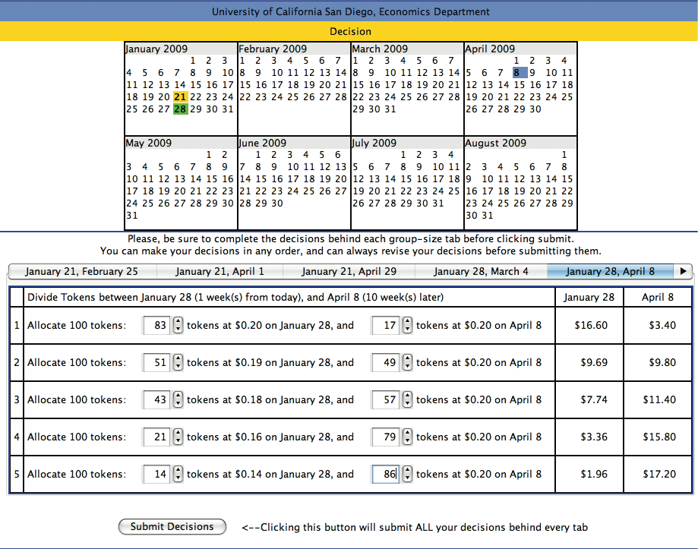
Subjects’ decision screens displayed a dynamic calendar and a series of nine “decision tabs.” These decision tabs corresponded to the nine choice sets described above, one tab for each (t, k) combination. Subjects could respond to the decision tabs in any order they wished. Each decision tab had five budget decisions presented in order of increasing interest rate and then in order of increasing budget. An image of the decision screen is presented in Figure 1.
For each decision, individuals were told how many tokens they were to allocate (always 100), the sooner token value at, and the later token value at+k. As each budget decision was being made, the calendar in the subjects’ screen highlighted the experiment date (in yellow), the sooner date t (in green), and the later date t + k (in blue). This allowed subjects to visualize the delay length for a given decision.
Our adaptation of the task:
In our adapted version of the task, participants are faced with 24 decisions in the gains domain (as outlined above) and 24 decisions in the losses domain (total of 48 decisions). In the losses framework, respondents are given an initial endowment of 1600 KSH sooner and 1600 KSH later and are asked to make decisions about allocating varying amounts to a sooner loss and a later loss in the future. Below is an example of the maximum earlier and later allocations that participants will make across three timeframes: 2 weeks from today vs. 4 weeks from today, today vs. 4 weeks from today, and today vs. 2 weeks from today. The losses domain consists of the same amounts and timeframes, with the only difference being that values are shown as negative amounts to indicate a loss from the initial endowment of 1600 KSH earlier and 1600 KSH later:
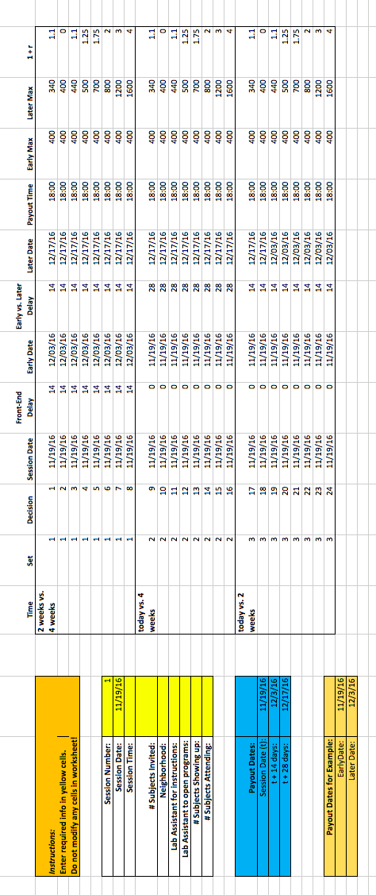

Example screenshots from the task:

Instructions screen
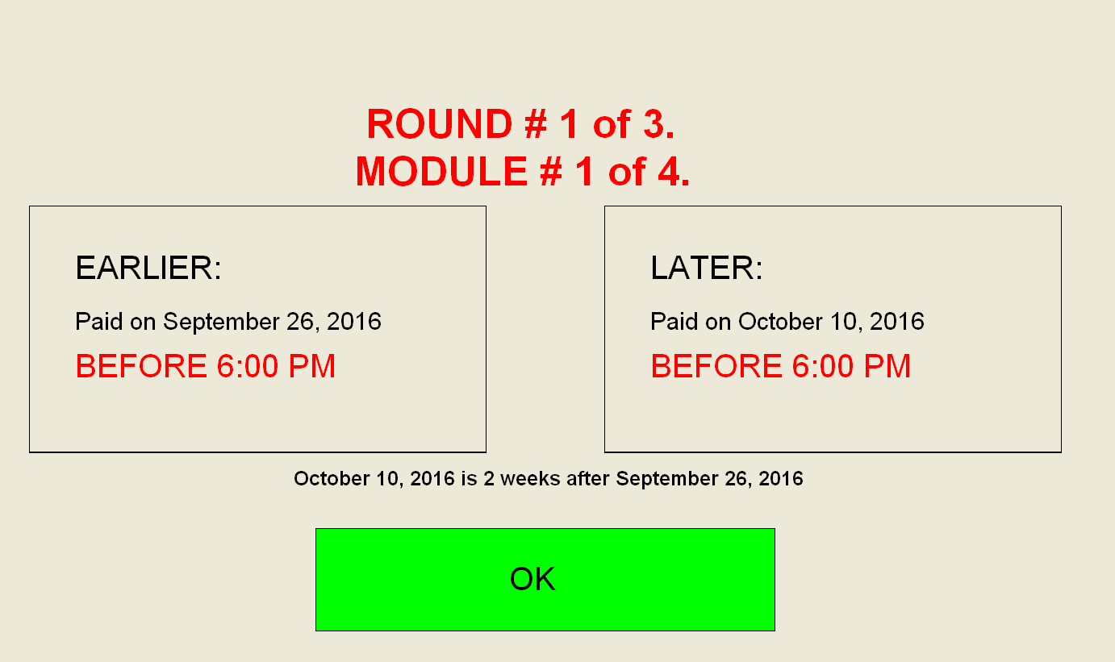

Gains screen (Decision 1)

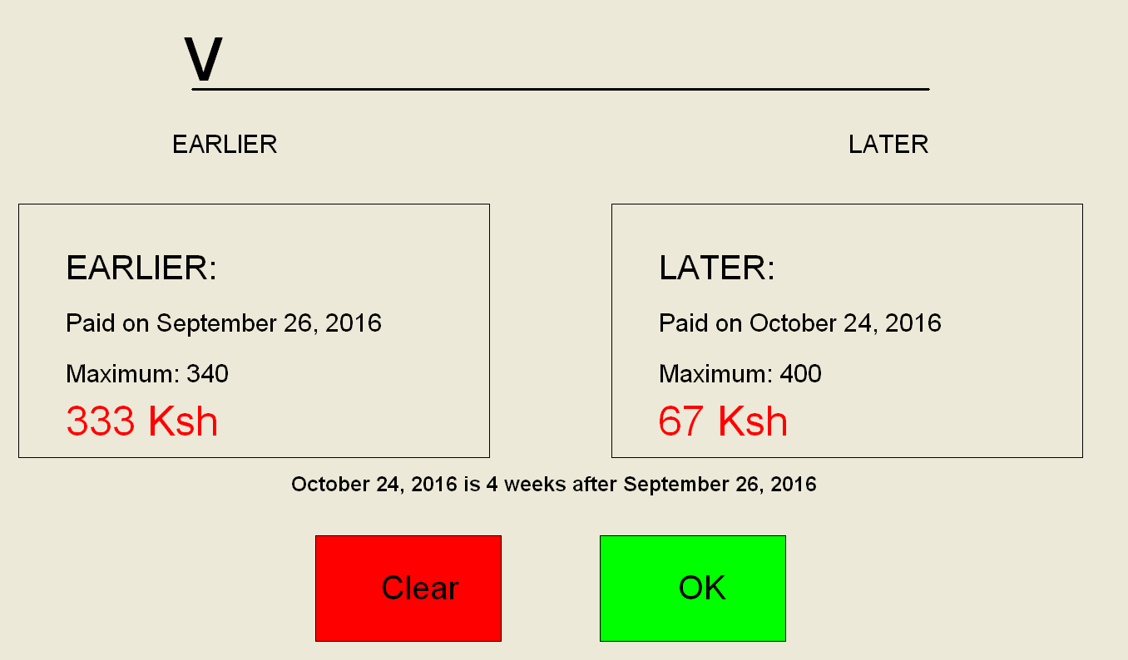

Losses screen (Decision 1)
